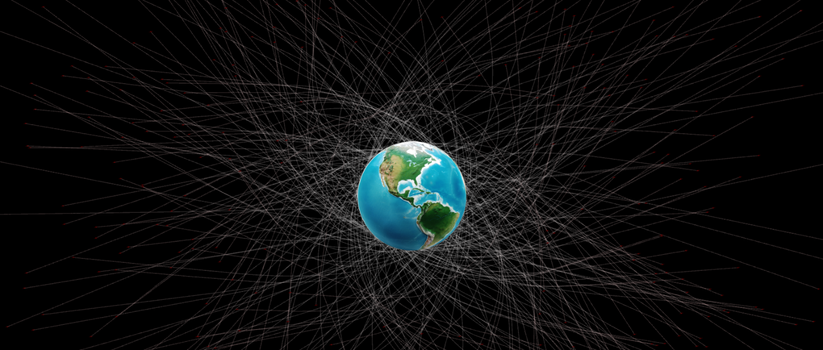

Genetic Algorithm – Mission Moon

Results Report

# Fitness Function 1:

FF1 is considers Minimum distance from moon ever recorded in a satellites journey time.

It is mapped between in the following way:

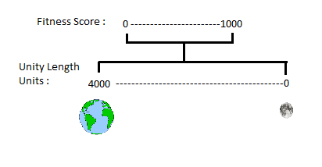

# F(x) = 1000 – (x/4);

**Results when mutation is set to 2% :**

Results when Mutation rate is 4%:

Results when Mutation rate is 10%:

Results when Mutation Rate is 25;

## Fitness Function 2:

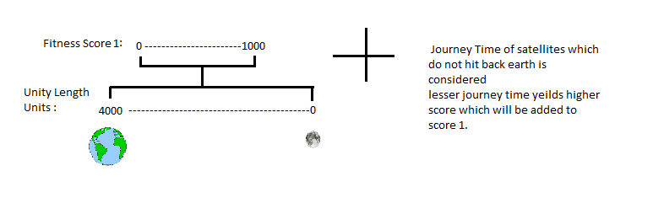

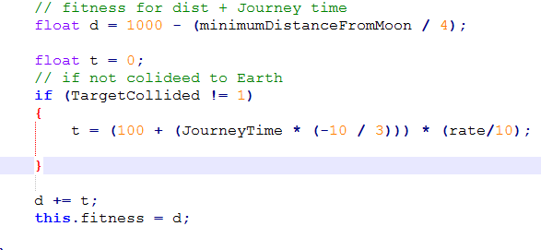

Results when Mutation Rate is 2%:

Results when Mutation Rate is 4%:

Results when Mutation Rate is 10%:

Results when Mutation Rate is 25%:

Mutation Rate Comparison (Fitness Function 1):

Mutation Rate Comparison (Fitness Function 2):